1.2 POSTCARD BACKS AND PRINTING PAPERS

A large number of cards were printed by the normal photographic process, often in the photographer's own darkroom. A wide variety of print papers were available, many of which were printed on the reverse side as postcards. So, in the case of 'real photo' cards, the design on the back is often not of great significance, and merely shows what paper was in stock at the time! However, varying designs may help ultimately to date cards. Quite apart from their use by major publishers, particularly the Valentine Group and the Rose Stereograph Company, many amateurs used such papers to print their own personal photographs. Even others simply used their Kodak Box Brownie (the equivalent of today's Instamatic) with Kodak 116 film (which produced a postcard size negative) to take family snapshots, then delivered the film to the local pharmacist for processing - he then used one or another of the readily available printing papers and so provided prints with a postcard back.

VALENTINE

This group of companies, part of a worldwide printing and publishing operation, produced cards for many areas of Australia. John Valentine, who engraved blocks for linen printing, first established the initial company in Dundee, Scotland in 1825. By the 1850's, his son James had made his mark as a landscape photographer and had also pioneered the printing of pre-stamped envelopes. Thus, in 1895, he was ready to commence the publishing of postcards. From the early years of this century, the company had four factories in Britain, the largest of which 'produced between one and two tons of postcards each working day!' Factories were also established in Montreal, Cape Town, Melbourne and Sydney. (Byatt 1978, pp. 301-322; Cook 1986, pp. 153-4) Some of the companies continue to produce postcards to this day, and those in Australia remain as leading printers, having been the first in this country to introduce computerised type-setting. The Australian postcards we have seen give various company names, and the backs used can be distinguished as listed below

The Valentine & Sons Publishing Co. Ltd. (all printed in Great Britain)
- Printed in blue or grey with double dividing line
- Sydney (1 in lower R.H. stamp box) V1
- Sydney (stamp box is blank) V1b
- Sydney (2 in upper L.H. stamp box) V2
- Sydney (3 in upper R.H. stamp box) V2b
- Melbourne (2 in upper L.H. stamp box) V3
- Melbourne (3 in upper R.H. stamp box) V3b
- Melbourne & Sydney (4 in upper L.H. stamp box) V4
- Printed in black with single (short) dividing line
- Melbourne V5
The Valentine Publishing Co. (printed in Great Britain)
- Melbourne, Sydney, Adelaide; O in lower R.H. stamp box;
- has two globes emblem V6
- Melbourne; 2B-2 in lower R.H. stamp box V6b
- Sydney & Melbourne; K in lower R.H. stamp box V6c
- Sydney & Melbourne; A in lower R.H. stamp box V6d

The Valentine & Sons Publishing Co. Ltd. (printing not specified)
- Melbourne, Sydney & Brisbane; ornate V encloses
'Valentine's/Real Photo Series/Post Card';
stamp box lists 7 world branches V7

The Valentine Publishing Co. Pty. Ltd. (printing not specified)
Queen St., Melbourne; Ornate V encloses 'Valentine's / Real
Photo Series'; no stamp box V8a
‘Valentines’ appears on map of Australia V8b

Valentine Publishing Co. (printing not specified)
- Melbourne & Sydney ; otherwise as V8 V9
- Valentine's/Post Card/A Genuine Photograph V10
- as V10 but without Valentine name V10b
- Valentine's/Post Card/Sending you Greetings V11
- Valentines Series (printed in Great Britain) V12

MISCELLANEOUS REAL PHOTO BACKS

Many of the printing papers used for real photo cards are only found on a relatively small number of cards.

RP1
(1907-08)


RP2
(1905-07)
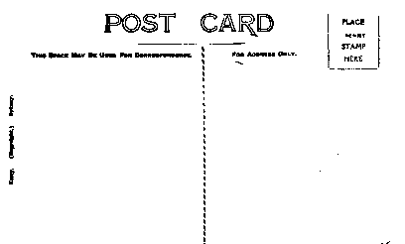

Both of the above are amongst the more often seen. We suspect, but have no proof, that they were produced by Baker and Rouse, a Melbourne-based company that was acquired by Kodak as the basis of their Australian operation.

RP3


RP4

RP5

Multi-lingual

ML1
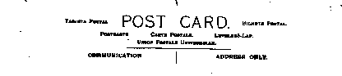

ML2
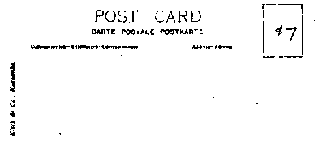
Satrap
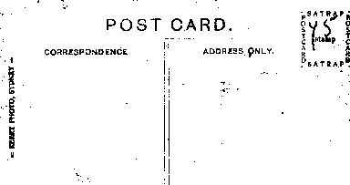

Empire
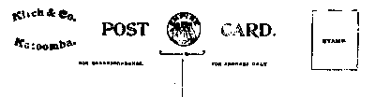
(produced by Harrington's Ltd. at least from 1903 onwards - blank sensitised
paper sold at 1/- per box of 12 sheets.)

